GE_IV_4: Superposition of two collinear oscillations having different frequencies (Beats):
The two SHM acting upon a particle is given by
Y₁ = a sin ωt = a sin 2 лnt

Y₂ = b sin ω₁t = b sin2 л(n+ ѵ)t

Where ω = 2лn and ω₁ = 2 л(n+ ѵ) and ѵ is the difference of frequencies of two motions, Y₁ and Y₂ are the displacement at any instant , a and b are the amplitudes. The second one of higher frequency by ѵ.
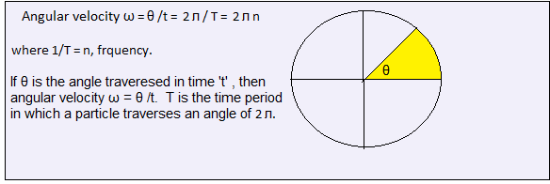
The resultant motion is given by
Y = Y₁ + Y₂

= a sin 2лnt + b sin2 л(n+ ѵ)t

= a sin 2лnt + b sin2лnt . cos2лѵt + b cos2лnt . sin2лѵt

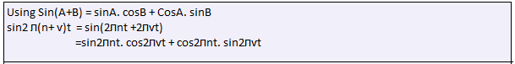

= sin2лnt (a + b cos2лѵt) + (b sin2лѵt ) cos2лnt

Putting (a + b cos2лѵt) = A cosϵ and b sin2лѵt = A sinϵ, the equation becomes

Y = A sin2лnt. cosϵ + A cos2лnt . sinϵ

= A sin(2лnt+ϵ) … … … … … … … … …… ……… …… …….(1)

And,
(A sinϵ)² + (A cosϵ)² = (b sin2лѵt)² + (a + b cos2лѵt)²

→ A² = a² + b² + 2ab cos2лѵt … …. …. …. …… …. … … (2)

Also, A sinϵ/ A cosϵ = tanϵ = b sin2лѵt/ a + b cos2лѵt

Or, ϵ = tan⁻¹ = $\frac{ b sin2лѵt}{a + b cos2лѵt}$ … … … … … … (3)

Where A is the amplitude of the resultant motion which depends upon time (eqn.-2) and ϵ is the phase difference which also depends upon time(eqn.-3).

From eqn. 2, when t=0,
A² = a² + b² + 2ab = (a + b )²

Or, A = (a + b) which is maximum.

When t = 1/2ѵ,
A² = a² + b² + 2ab cos2лѵ(2ѵ)

= a² + b² + 2ab cosл

= a² + b² - 2ab

= (a – b)²

Or, A = (a – b), which is minimum.

Similarly, when t = 1/ ѵ, A= (a + b); when t = 3/2 ѵ, A = (a – b); when t = 2/ ѵ, again A= (a + b).
Thus the max^{m} amplitude (a + b) or 2a when a=b of the resultant motion is occurring at t=0, 1/ ѵ, 2/ ѵ etc. i.e., at regular interval of time 1/ ѵ.
The min^{m} amplitudes (a – b) or 0(zero) when a=b are occurring at time 1/2 ѵ, 3/2 ѵ etc. i.e., at regular interval of time 1/ ѵ.
In order to notice these changes the difference between the frequencies ѵ of the two components motion should be very small.
The amplitude of the resultant vibrations is sometime maximum and other time minimum, the time interval between the two maxima or the time interval of two minima is equal to 1/ ѵ. This is known as ‘beat’.

