VI_15: Reciprocal lattice to fcc lattice:
If we draw a fcc lattice and consider three face centered lattice point P, Q and R, we will get the translational lattice vectors $\vec{a}$ , $\vec{b}$ and $\vec{c}$ as
$\vec{a}$ = $\frac{a}{2}$ ($\hat{i}$ + $\hat{j}$ ), $\vec{b}$ = $\frac{a}{2}$ ($\hat{j}$ + $\hat{k}$ ) and $\vec{c}$ = $\frac{a}{2}$ ($\hat{k}$ + $\hat{i}$ )
(* See the box 2 in the previous note).
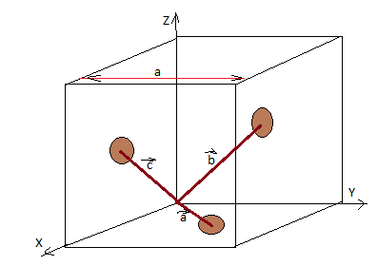
Also, the reciprocal translational vectors are given by:
$\vec{A}$ or a* = 2л $\frac{(\vec{b} x \vec{c})}{\vec{a} . (\vec{b} x \vec{c}) }$ , $\vec{B}$ or b* = 2л $\frac{(\vec{c} x \vec{a})}{ \vec{b} . (\vec{c} x \vec{a})) }$ and $\vec{C}$ or c* = 2л $\frac{(\vec{a}x \vec{b})}{ \vec{c} . ((\vec{a}x \vec{b}) }$
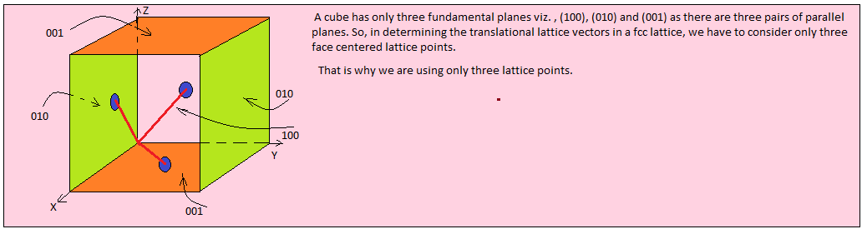
Now,
$(\vec{b} x \vec{c})$ = $\frac{a}{2}$ ($\hat{j}$ + $\hat{k}$ ) x $\frac{a}{2}$ ($\hat{k}$ + $\hat{i}$ ) = ( a² /4 ) [ (($\hat{j}$ + $\hat{k}$ ) x ($\hat{k}$ + $\hat{i}$ ) ]
If we make a determinant with the multiplying factors of the unit vectors, we get
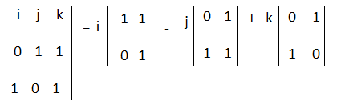
= $\hat{i}$ ( 1 – 0 ) - $\hat{j}$ (0 – 1 ) + $\hat{k}$ ( 0 – 1 )

= $\hat{i}$ + $\hat{j}$ - $\hat{k}$

So, $(\vec{b} x \vec{c})$ = ( a² /4) ($\hat{i}$ + $\hat{j}$ - $\hat{k}$ )
And,
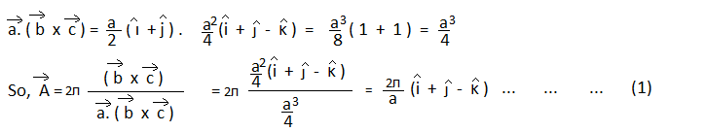

Again,
$(\vec{c} x \vec{a})$ = $\frac{a}{2}$ ($\hat{k}$ + $\hat{i}$ ) x $\frac{a}{2}$ ($\hat{i}$ + $\hat{j}$ ) = (a²/4) [($\hat{k}$ + $\hat{i}$ ) x ($\hat{i}$ + $\hat{j}$ ) ]
Making again a determinant, we have
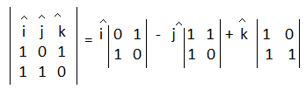
= $\hat{i}$ ( 0 – 1 ) - $\hat{j}$ ( 0 – 1 ) + $\hat{k}$ ( 1 – 0 )

= - $\hat{i}$ + $\hat{j}$ + $\hat{k}$
So,
$\vec{c} x \vec{a}$ = (a²/4) (- $\hat{i}$ + $\hat{j}$ + $\hat{k}$ ) and $\vec{b}$ . ($\vec{c} x \vec{a}$ ) = a³/4.

Hence, $\vec{B}$ or b* = $\frac{2л}{a}$ (- $\hat{i}$ + $\hat{j}$ + $\hat{k}$ ) …. ……….. ………. ……… (2)
Similarly, we can determine
$\vec{C}$ or c* = $\frac{2л}{a}$ ( $\hat{i}$ - $\hat{j}$ + $\hat{k}$ ) … … … … … … … (3)
The vectors a*, b* and c* are the reciprocal lattice vectors of fcc lattice. These are also the primitive translation vectors of a bcc lattice (real lattice). Thus, the reciprocal lattice to an fcc lattice is a bcc lattice.

