VI_14: Reciprocal lattice of BCC lattice:
Let us consider a bcc lattice with respect to $\vec{a}$ , $\vec{b}$, $\vec{c}$ (fig-1). We consider an another bcc cell as in
(fig-2). Again, we consider a third unit cell as in fig-3. To make a reciprocal lattice, we have to select an origin and let it be O. We consider three axes from the origin. So, we have three bcc unit cells in real space with three body centered lattice point P, Q, R.
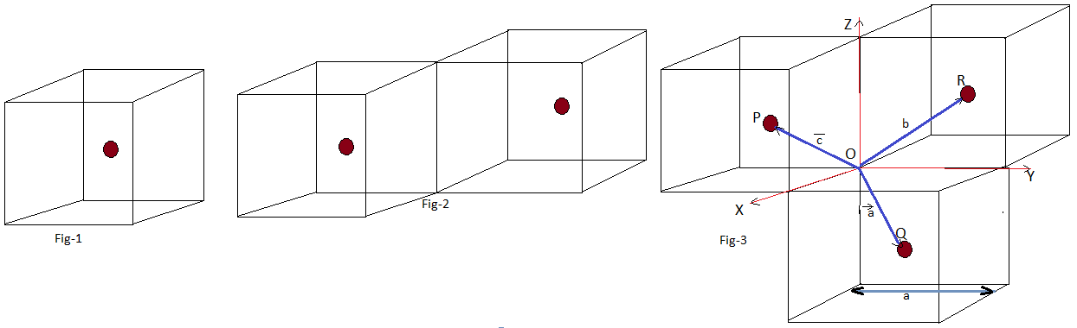
All cubes have its edge length ‘a’ (Don’t confuse it with the translational primitive vector $\vec{a}$ ). Now, the three points P, Q, R are at the mid of each real unit cell. So, the primitive translation vectors of the body centered cubic lattice are:
$\vec{a}$ = $\frac{a}{2}$ ( $\hat{i}$ + $\hat{j}$ - $\hat{k}$ ), $\vec{b}$ = $\frac{a}{2}$ (- $\hat{i}$ + $\hat{j}$ + $\hat{k}$ ) , $\vec{c}$ = $\frac{a}{2}$ ( $\hat{i}$ - $\hat{j}$ + $\hat{k}$ ) … … … (1)*
Where $\hat{i}$ , $\hat{j}$ , $\hat{k}$ are unit vectors along x-, y- and z-axis respectively, which are called orthogonal unit vectors.
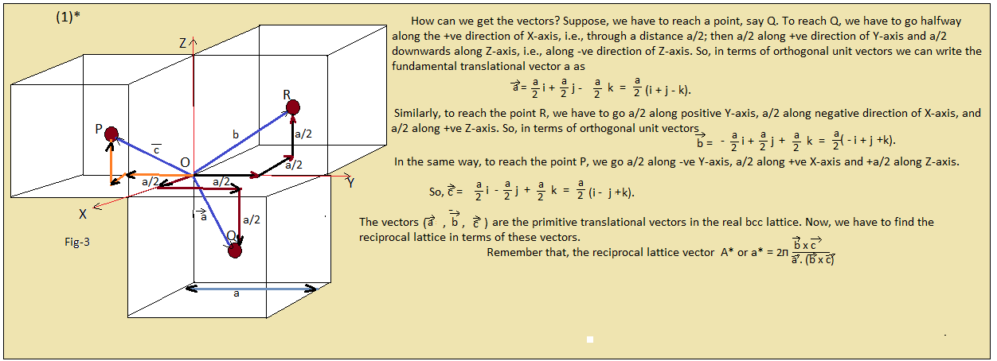
Now,
$\vec{A}$ = a* = 2$π$ $\frac{\vec{b} X \vec{c} }{\vec{a} .(\vec{b} X \vec{c})}$

$\vec{b} X \vec{c}$ = $\frac{a}{2}$ (- $\hat{i}$ + $\hat{j}$ + $\hat{k}$ ) x $\frac{a}{2}$ ( $\hat{i}$ - $\hat{j}$ + $\hat{k}$ ) = a²/4 { (- $\hat{i}$ + $\hat{j}$ + $\hat{k}$ ) x ( $\hat{i}$ - $\hat{j}$ + $\hat{k}$ ) }
If we make a determinant (with the multiplying factors of $\hat{i}$, $\hat{j}$ and $\hat{k}$ ) it will be like
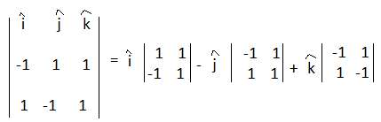
= $\hat{i}$ (1 + 1) - $\hat{j}$ ( -1 – 1) + $\hat{k}$ ( 1 – 1)
= 2 $\hat{i}$ + 2$\hat{j}$
=2( $\hat{i}$ + $\hat{j}$ )
So, $\vec{\begin{aligned} \\ b\end{aligned}} X \vec{c}$ = (a²/4 ). 2( $\hat{i}$ + $\hat{j}$ ) = (a² /2) $(\hat{i}$ + $\hat{j}$ )

Volume V = $\vec{a}$ . ($\vec{b} X \vec{c} )$ = $\frac{a}{2}$ ( $\hat{i}$ + $\hat{j}$ - $\hat{k}$ ) . (a² /2) $(\hat{i}$ + $\hat{j}$ ) = (a³/4)( ( $\hat{i}$ + $\hat{j}$ - $\hat{k}$ ) . $(\hat{i}$ + $\hat{j}$ )

= (a³/2 ), as $\hat{i}$ . $\hat{i}$ = $\hat{j}$ . $\hat{j}$ = 1 and $\hat{i}$ . $\hat{j}$ = $\hat{j}$ . $\hat{k}$ = 0.
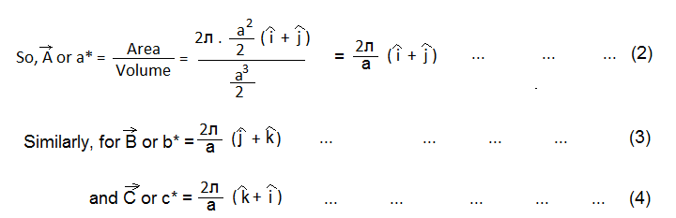

Equations (2), (3) and (4) represents the reciprocal primitive lattice vectors in terms of real lattice primitive translational vectors ( in terms of $\vec{a}$ , $\vec{b}$ and $\vec{c}$ ). These are also the primitive translational vectors of an FCC lattice. So, the reciprocal lattice to a BCC lattice is a FCC lattice.
( For proof, see the box-2).
