S_VI_13:
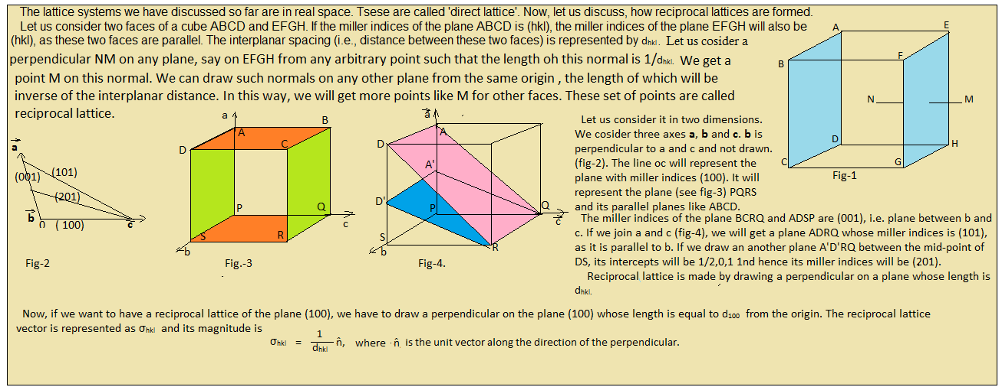

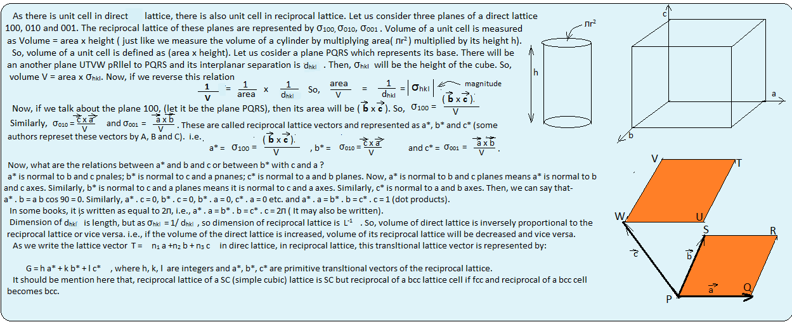

Rules for constructing the reciprocal lattice:
1.Draw normal to every set of planes from the origin point in the direct lattice.
2.For a particular set of planes, set the length of each normal equal to the reciprocal of the interplanar spacing.
3.Put a point at the end of each normal.
The collection of points so obtained gives us a new lattice array called reciprocal lattice.

Reciprocal lattice of a SC lattice:
Since it is a cube, so its all arms are equal, say equal to ‘a’. In this lattice, lattice vectors $\vec{a , }$ $\vec{b }$, $\vec{c }$ are written as $\vec{a }$ = a$\hat{i}$ , $\vec{b }$ = a$\hat{j}$ , $\vec{c }$ = a$\hat{k}$ .
So, we have to generate reciprocal lattice vectors for it. 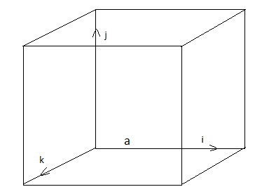

Now, a* = $\frac{\vec{b }\vec{ Xc }}{\vec{a } . \vec{b } X \vec{c }}$ or, a* = 2л $\frac{\vec{b X }\vec{c }}{a . b X c}$ (as in some books, 2л is multiplied, both are correct)

(a . b x c) represents volume.
(a . b x c) = a$\hat{i}$ . a$\hat{j}$ x a$\hat{k}$ = a³ ($\hat{i}$ . $\hat{j}$ x $\hat{k}$ ) = a³ ($\hat{i}$ . $\hat{i}$ ) = a³ .1 = a³ = volume of the cube (as $\hat{j}$ x $\hat{k}$ = $\hat{i}$ ).

So, a* = $\frac{\vec{b X }\vec{c }}{a . b X c}$ = $\frac{a\hat{j} x a\hat{k} }{a3}$ = (a²/a³)$( \hat{j}$ x $\hat{k}$) =$\frac{1 }{a}\hat{i}$

Or, if we include the 2л (as in some books) , a* = $\frac{2л }{a}\hat{i}$
Similarly for b* = $\frac{\vec{c X }\vec{a }}{a . b X c}$ = $\frac{1 }{a}\hat{j}$ or, b* = $\frac{2л }{a}\hat{j}$ and c* = $\frac{1 }{a}\hat{k}$ or = $\frac{2л }{a}\hat{k}$ .

Thus, the reciprocal lattice vectors a*, b* and c* are similar to $\vec{a }$, $\vec{b }$ and $\vec{c }$ except that they are multiplied by $\frac{1 }{a}$ (or by $\frac{2л }{a}$ ). So, construction of a reciprocal lattice vector of the simple cubic (SC) cell will be similar to that of direct sc lattice except with different length of arms.
Thus, all the three reciprocal lattice vectors are equal in magnitude which means that the reciprocal lattice to sc lattice is also simple cubic .

