VI_10: NaCl structure:
In sodium chloride, crystals are bound together by an ionic bond. In NaCl, Na atom losses its outer electron and so acquires an excess positive charge while the Cl atom acquires an excess negative charge by accepting the electron lost by the Na atom. Two such ions will attract each other and approaches to a certain distance. But a strong repulsive force is set in due to other outer shells and attains an equilibrium when the force of attraction and repulsion become equal.
The Bravais lattice is face-centered cube. The basis consists of one Na and one Cl atom separated by one-half the body diagonal of a unit cube.
Therefore, it can be considered as two face-centered cube sub-lattices, one of Na ions having its origin at the point (0,0,0) and the other of Cl ions having its origin mid-way along a cube edge, say at points (a/2,0,0).
There are four units of NaCl in each unit cube with atoms in position:
Na⁺ : (0, 0 ,0), (1/2,1/2,0), (1/2,0,1/2), (0,1/2,1/2)
Cl⁻ : (1/2,1/2,1/2), (0, 0, 1/2), (0, ½ ,0), (1/2, 0, 0).
Each atom has six atoms as nearest neighbor of the opposite kind. So, co-ordination number is six.
The lattice is simple cubic if the difference between Na and Cl ion positions is ignored.
Ionic radius of Cl⁻ is 1.18 Å and that of Na⁺ is 0.92 Å. As r_{Cl} $>$ r_{Na,} hence Cl occupies the corner and face- centered position. Na ion occupies the octahedral voids.
Total number of chloride ions per unit cell = eight corner atoms + six face centered atoms
= (1/8 x 8) + ½ x 6 ) = 4.
Total number of Na atoms = sum of Na ions at the 12 edges and one at the center of cube
= 12 edges x ¼ per edge + 1 ion in the center = 4.
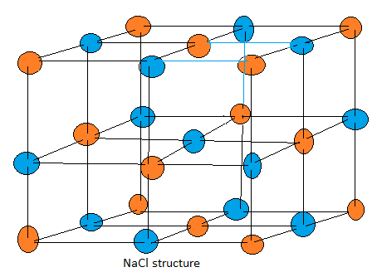

For NaCl, a = 2 (r_{Na} + r_{Cl} )

