(Sem_VI_6.) : Face Centered Cubic (FCC):
In the face-centered cubic or cubic F-lattice, there are eight lattice points at the corners of the unit cell and also it contains lattice points at the center of each face. i.e. there is an extra lattice point at the center of each face of the fcc lattice unit cell.
In the fcc lattice, there are eight lattice points at eight corners and contribution of these eight lattice points to the unit cell = 1/8 x 8 = 1.
In addition, there are six faces of the unit cell each atom of which belongs to two unit cells. So, the contribution of these six lattice points to the unit cell = ½ x 6 =3.
Thus, total number of lattice points per fcc cell = 1 + 3 = 4.
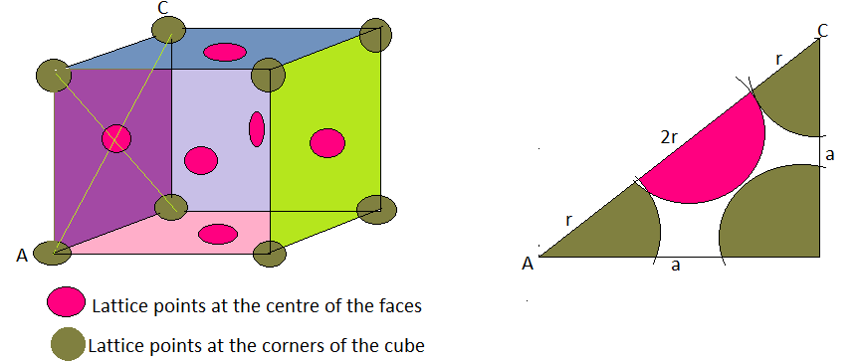
Face diagonal of the FCC unit cell is AC² = a² + a² = 2 a²

Or, AC = $\sqrt{2}$ a = 4r

Or, r = $\frac{\sqrt{2}}{4}$ a … … … … (1)

= $\frac{a}{2\sqrt{2}}$ … … … … (2)

The nearest neighbor distance d = 2r = $\frac{a}{\sqrt{2}}$ … .. (3)

Now, total volume of 4 atoms = 4 . $\frac{4}{3}$ л r³

= 4 . $\frac{4}{3}$ л ($\frac{\sqrt{2}}{4}$ a )³ = $\frac{\sqrt{2}}{6}$ л a³

And volume of the unit cell V = a³

Hence, Packing fraction = $(\frac{\sqrt{2}}{6}$ л a³) / a³ = $\frac{\sqrt{2}}{6}$ л = 0.74

In terms of percentage PF = 74%
Thus, FCC structure has highest packing fraction compared to SC and BCC structure.
Examples : Aluminium, Silver, Copper, Lead etc.

