Some simple crystal structures (sc, bcc, hcp…..)
- Simple cubic crystal structure:
Simple cubic structure is the simplest cubic system. In simple cubic(SC) lattice, there are eight lattice points at the corners of the unit cell. The unit cell cell for simple cubic structure contains one-eight (1/8) portions of eight corner atoms to make one complete atom, molecule or ion in each unit cell, i.e. for an sc lattice, there is one lattice point per unit cell. (or, every lattice point in sc lattice, situated at the corner of the unit cell is shared by eight unit cells).
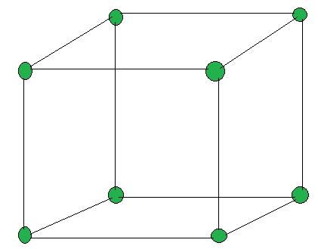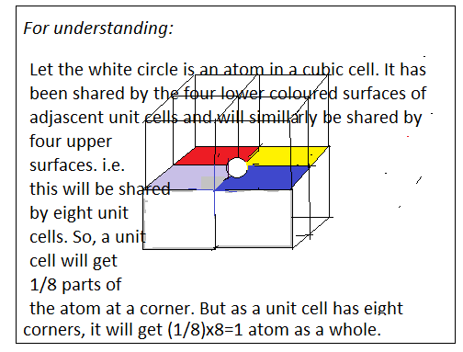
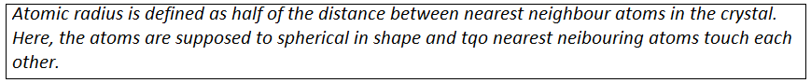
Here, AB represents the radius r of an atom, and r = a/2.
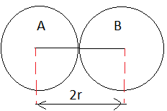
For SC, the nearest neighbor distance distance, d= 2r = 2 (a/2) = a.
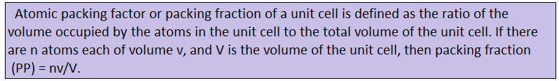
In SC structure, there is one atom in the unit cell. Volume of the atom of radius ‘ r ‘ is
V = $\frac{4}{3}$ л r³ = $\frac{4}{3}$ л (a/2)³ = $\frac{лa3 }{6}$ .
Volume of the unit cell V = a³
Hence, PF = $\frac{1.v}{V}$ = $\frac{1}{a3}$ . = $\frac{лa3 }{6}$ = $\frac{л}{6}$ = 0.523.
If it is expressed in percentage (what percentage of the unit cell is occupied by the atoms) then
% PF = PF x 100 = 52.3 %.
The structure is thus loosely packed.
Examples : KCl, Po (Polonium) etc.

