S_VI_16: Concept of Brillouin zone :
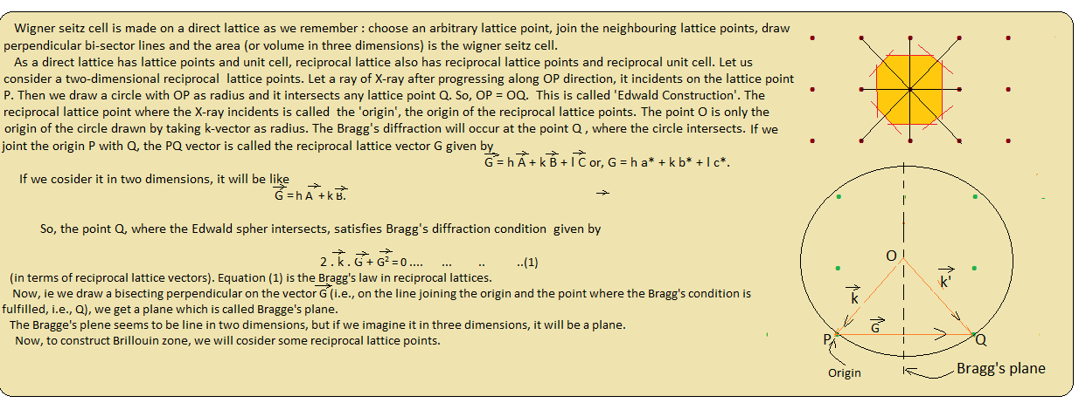
Let us consider a number of reciprocal lattice points and we choose any point (say R) as origin. Then we have to join the neighboring reciprocal lattice points (as we do for constructing Wigner seitz cell in real lattice). Now, let us draw perpendicular bi-sectors on the lines joining the arbitrary origin(R) and any neighboring reciprocal lattice point. These are all Bragg lines ( in two dimensions) or Bragg planes in three dimensions.
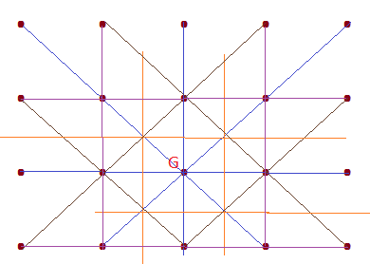

Now, let us omit the imaginary lines joining the origin and the neighboring reciprocal lattice points, remaining only the Bragg planes. Let us then go along any direction, but do not cross any Bragg plane. The area (or volume in three dimensions) enclosed in this way is the first Brillouin zone. Now if we cross the first Bragg plane but do not cross the second plane, then the area we get is the 2nd Brillouin zone, i.e. the area (or volume ) between the first and second Bragg planes. Similarly, 3rd Brillouin zone is the region between 2nd and 3rd Bragg planes etc. So, nth. Brillouin zone will the region between the nth. And (n-1)th. Bragg planes.
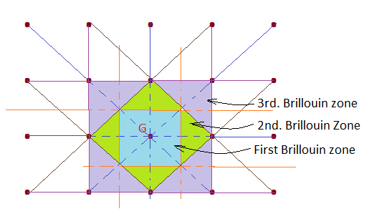

Brillouin zones play important roles in understanding the electronic properties of crystals. It plays an important role in the theoretical understanding of the elementary ideas of electronic energy bands.

