VI_8: Diamond structure:
The diamond structure is a combination of two inter-penetrating face-centered-cubic sub-lattices. One sub-lattice has its origin at the point (0, 0, 0), and the other at a point one quarter of the way along the body diagonal (at the point a/4, a/4, a/4). The projection of atoms in the cubic cell of diamond cubic structure is shown in fig-1.
Since each atom has only four nearest neighbors, its co-ordination number is 4, and thus the diamond cubic structure is loosely packed.
There are eight corner atoms along with six face-centered atoms and four more atoms are presented in the unit cell. Again, each face-centered atom is shared by two unit cells and the corner atom is shared
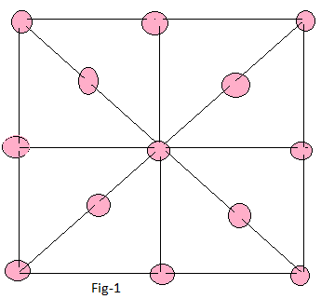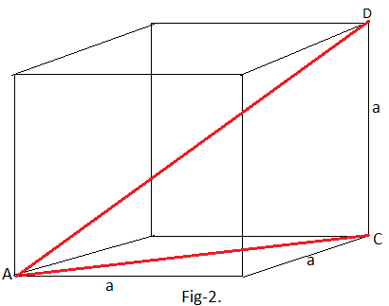
by eight adjacent unit cells. Hence, the number of atoms per unit cell
= ( $\frac{1}{2}$ x 6) + ($\frac{1}{8}$ x 8 ) + 4 = 8.
If ‘a’ be the cube edge,

AC² = a² + a² = 2 a²

AD² = AC² + CD² = 2 a² + a² = 3 a²

Or, AD ( Body diagonal) = $\sqrt{3}$ a.
There are three full spheres and two half spheres along the diagonal. If ‘r’ is the radius of the spherical atom,
AD = r + 3(2r) + r = 8r

Or, 8r = $\sqrt{3}$ a.

Or, a = $\frac{8r}{√3}$

Volume of the unit cell V = a³ = ($\frac{8r}{√3}$ )³

Volume of all atoms in the unit cell ѵ = 8 x $\frac{4}{3}$ $π$r³

So, packing fraction = $\frac{ѵ}{V}$ = (32 $π$r³/3)/( 8r/$\sqrt{3}$)³

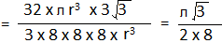

= 0.34
Or, PF = 34%
Thus, the structure is loosely packed. The unit cell of diamond is similar to that of germanium and silicon.
